NATIONAL UNIVERSITY OF MODERN LANGUAGE ISLAMABAD
Lab task:-04


Submitted to:
Mr. Meesam Raza
Submitted by:
Zulqarnain Hassan (SP21379)
Subject: …………………… Operating System
Department: ……………… BSSE-4-Afternoon
Date: ………………………. 25-03-2024

Task 1
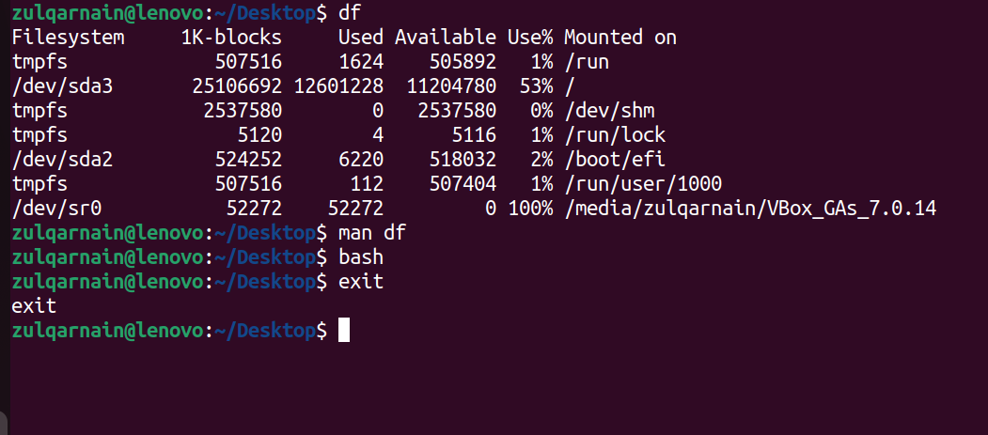

Task 2
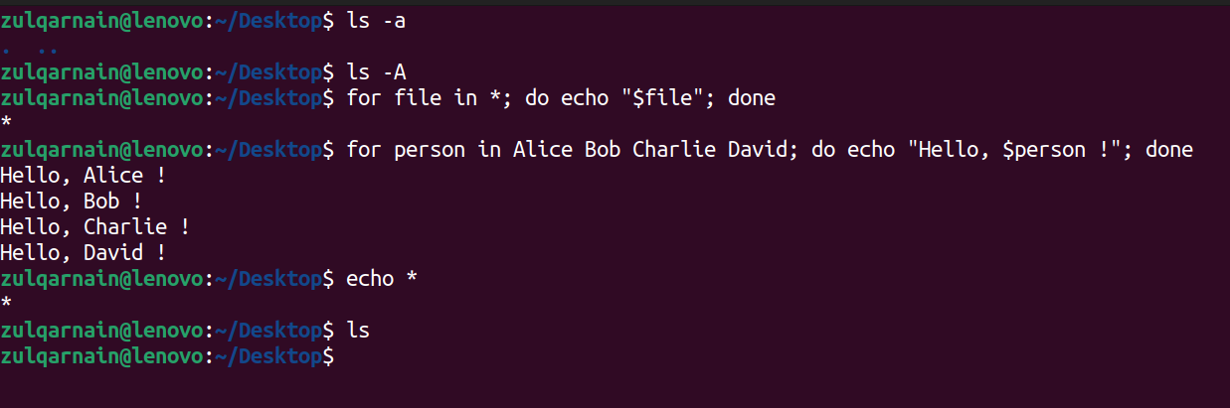

Task 3
